Homework: Automating Repetition for Security Tasks
CodeYou: CS Cohort Aug 25
B. Patterson-Morri

Output for Challenge 1 & 2
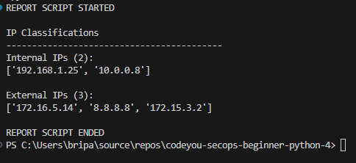

Challenge 3 output:
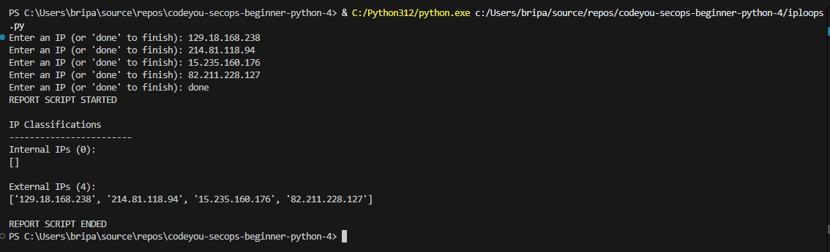

Reflection on what loops made easier:
- Loops made it easier to handle repetitive tasks without writing the same logic over and over, especially when working through a list of IP addresses. Instead of manually checking each value, the loop let the script apply the same rules consistently and efficiently. This helped me see how simple Python logic can scale to real security tasks like reviewing logs or filtering network data.

